Windows 8 Modern Apps: A Peek into Data Storage Options

Author: Deepthi Anantharaman, Technology Evangelist - DPE | Microsoft India

Abstract: Apps are gaining popularity across all platforms and devices. They often provide the most compelling feature at a quick glance empowering end users to make well informed decisions all the time. At the heart of a well-made app is the ability to provide quality and relevant data at the right time. This article focuses on various data storage options available for app developers. Choice of language and the quantum of data to be made available also influences data storage options
In good old days, data existed in memory (of the human brain) and passed on from the teacher to the student, from a mentor to the mentee, from parent to a child and hence forth. With the evolving human clan learning to record better and better, data was transferred to different mediums and finally now they persist in memory (of computer chips). There has been rapid progress and breath taking evolutions in the way data is now being gathered. As it became easier and cost effective on the storage front, more data is being stored. All data that is stored is consumed through data warehouses, business Intelligence systems, Management Information Systems which are manifested to scale in the form of parallel data warehouses and Big Data systems. While this is mostly apt in the context of setting up data repositories, one trend that is fast picking up is data visualization in the form of ‘Apps’.
‘Apps’ take center stage when it comes to data visualization. They convey key information and important features which makes difference for consumer to operate in “Always On” and “Always Connected” mode. Once an app is designed with an intuitive UI, easy navigation and animation to offer great user experience, attention turns towards the content. Data is pivotal in making the app useful for the consumer. Windows 8 /8.1 offers a number of ways to store and integrate data. As an app developer one needs to be aware of the data storage options that is available from a platform standpoint. This article brings out some of the storage options worth considering while building apps on Windows 8(aka Modern Apps)
Key Considerations: Size of data often determines if data needs to be stored remotely or locally. However Modern Apps will tend to use both as they need data to function aptly in the absence of network connectivity. There are some amazing apps built to showcase just data alone. For Line of Business (LOB) apps, data storage plays a vital role influencing architecture of the app.
Below visual depicts the various options we have in dealing with data storage for modern apps. We will delve into each of these to get a perspective of when to opt for which storage option
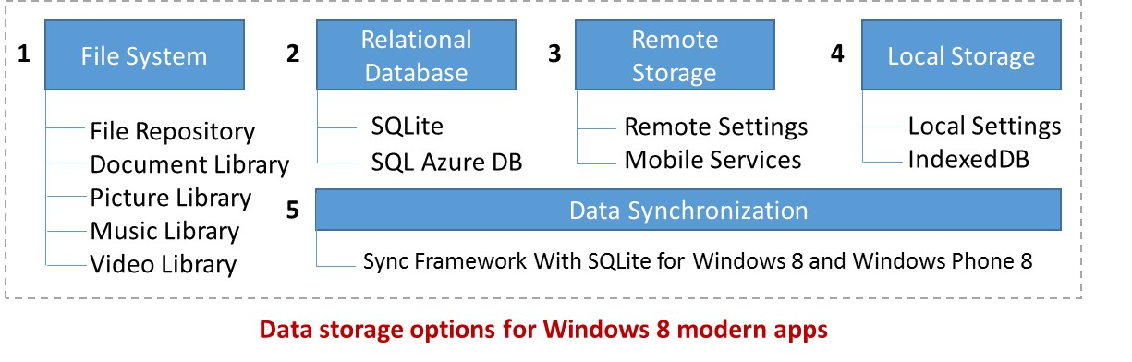

- File Systems
Along with using text files and XML files, built-in “file picker” or “contacts” are used as File System data sources. APIs can also be used for data manipulation. File picker apart from providing a navigational path to folders and files, allows us to choose another app as a location. This means apps can interact with each other. For example, a file opener can interact with Bing, Camera. In Windows 8, through contracts apps can interact with one another and share data.
Usage Scenario: File systems are best used when data quantities are small and data structures not complex. As there is no intermediate layer between the app and the file systems, it gives good performance too. Most ideal for static apps and apps with limited interactivity.
- Relational Databases
Relational databases handle complex data structures and recommended for apps with heavy data processing and visualization. SQLite is ideal for use with C#/XAML as the programming language. Indexed DB is ideal with HTML5/WinJS.
Usage Scenario: Apart from the traditional heavy data lifting databases, there are a few light weight DBs which require no set up and configuration. They are ideal with apps which will be installed on devices of different sizes.
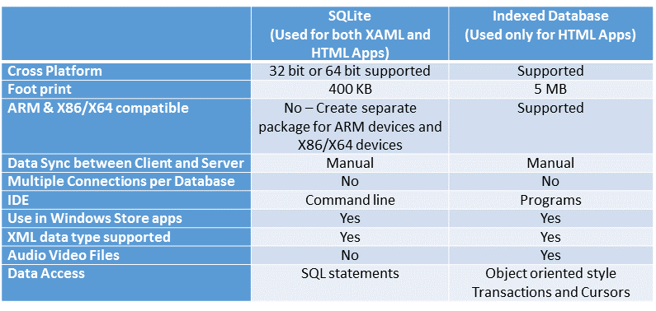

- Remote Storage
Any remote HTTP endpoint that serves JSON, XML or any other data protocols qualify via a façade qualify under remote storage. Behind the façade, data can be stored in any source. Public APIs for SkyDrive, Facebook or Flickr also serves as an example of remote storage.
Usage Scenario:
- SkyDrive is an excellent option for data storage. Users can store and access documents through File Open or Save Pickers. Saving to SkyDrive means zero worries about database management. There is 7 GB of default space available, post which users can purchase more storage. The Live API contains a fully featured REST’ful SkyDrive APIs for reading and writing to SkyDrive. Microsoft. Live namespace allows C# developers to access the Live and SkyDrive APIs, while JavaScript developers can make REST’ful calls with HTTP verbs POST or PUT. SkyDrive isn’t recommended for app configuration data.
- Azure Mobile Services: is a windows azure service offering where it gives an option for apps to create dynamic and functional apps. This is an excellent option if you can considering building a common façade for Windows 8, Windows Phone, iOS and Android apps too.
Outside of these public APIs, developers can access any web end point to push or pull data relevant to the app.
- Local Storage
Local storage comes into picture when the scenario demands storage of app data locally in order for the app to function during times of non-availability of network connectivity. They can be simple key value pair storage to file storage in the context of the app.
There is no database setup required and is a native behavior. Local Storage persists data after the app terminates

Usage Scenario: Being able to persist data locally between app sessions makes local Storage an excellent choice for supporting offline scenarios. Small data is mostly suited for offline support.

- Sync Framework
Microsoft Sync Framework is a comprehensive synchronization platform enabling data synchronization and offline data availability for applications, services and devices. Developers can build synchronization systems that integrate application, data from any store using any protocol over the network. Sync Framework features technologies and tools that enable roaming, sharing, and taking data offline.
While this is a great framework, the same is not available for Windows 8 Modern Apps. There is no out of the box automation available here, and the implementation is mostly manual. The Hub and spoke architecture needs to be manually implemented by a combination of client push and pull services to achieve data synchronization.
Usage Scenario: When there is a need to maintain integrity (single version of truth), data synchronization becomes a must.
Below summarizes the overall use cases, and qualifies as a quick reference to check on the data storage options
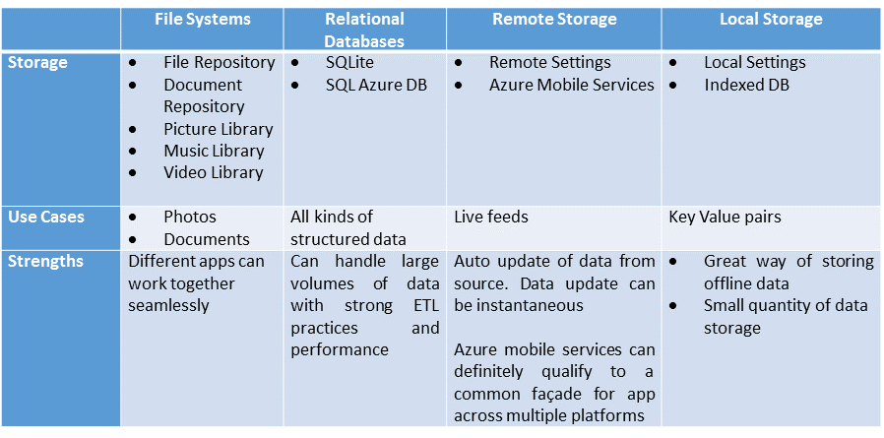

Some of the great apps that bring in data visualization by leveraging data stored either locally or remotely as indicated below. They are mostly for reference and evidence of how apt storage leads building high performing data visualization apps. Check out Bing News, Captain Dash, SAP Sales Pipeline Stimulator, SAP EMR Unwired. Check out Windows Store and Windows Phone store for more apps. Data Storage is not just relevant for LOB apps, but apps in general.

In summary, Data storage options are many and has to be chosen depending on what the scenario demands. Windows 8/8.1 platform is just a year old, evolving and more options will become mainstream with time. Having said that, there is no dearth of options now to build functional and dynamic apps that scales across form factors and platforms. All the great apps in Windows store that provides data storage, offline capability and roaming options have embraced one or more of the options discussed in this article.

About the Author

Deepthi works with Microsoft Corporation, India as a Technology Evangelist. In her present role, she works with developers across India evangelizing Microsoft Technologies.

